# Task C5.2.1

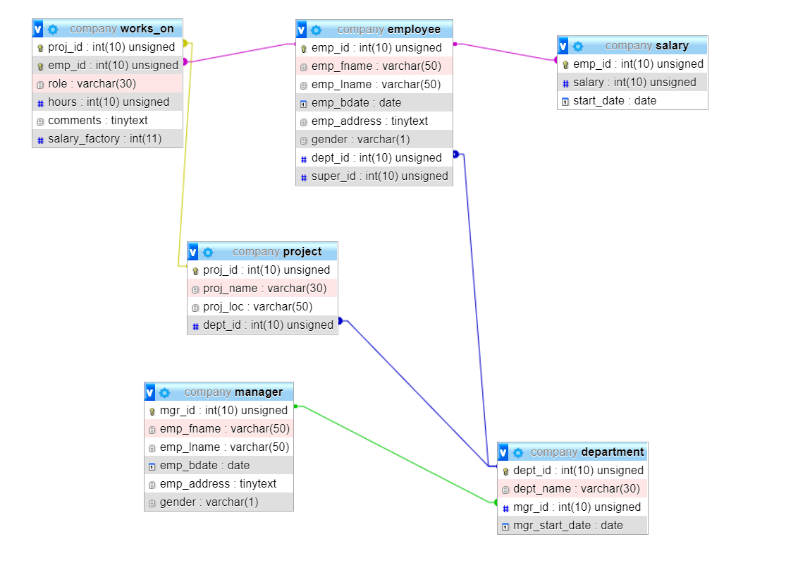

CREATE TABLE Manager (

mgr_id INT UNSIGNED NOT NULL,

emp_fname VARCHAR(50) NOT NULL,

emp_lname VARCHAR(50) NOT NULL,

emp_bdate DATE NOT NULL,

emp_address TINYTEXT NOT NULL,

gender ENUM('M','F','U') CHECK (gender in ('M', 'F', 'U')),

PRIMARY KEY (mgr_id)

);

* **new manager table to incorporate manager information**

CREATE TABLE Department (

dept_id INT UNSIGNED NOT NULL,

dept_name VARCHAR(30) NOT NULL,

mgr_id INT UNSIGNED NOT NULL,

mgr_start_date DATE NOT NULL CHECK (date < CURRDATE()),

PRIMARY KEY (dept_id),

FOREIGN KEY (mgr_id) REFERENCES Manager(mgr_id)

);

CREATE TABLE Employee (

emp_id INT UNSIGNED NOT NULL,

emp_fname VARCHAR(50) NOT NULL,

emp_lname VARCHAR(50) NOT NULL,

emp_bdate DATE NOT NULL,

emp_address TINYTEXT NOT NULL,

gender ENUM('M','F','U') CHECK (gender in ('M', 'F', 'U')),

dept_id INT UNSIGNED NOT NULL,

super_id INT UNSIGNED NOT NULL,

PRIMARY KEY (emp_id),

FOREIGN KEY (dept_id) REFERENCES Department(dept_id)

);

*ALTER TABLE employeE MODIFY COLUMN gender ENUM('M','F','U') CHECK (gender in ('M', 'F', 'U'));

CREATE TABLE Project(

proj_id INT UNSIGNED NOT NULL,

proj_name VARCHAR(30) NOT NULL,

proj_loc VARCHAR(50) NOT NULL DEFAULT 'company',

dept_id INT UNSIGNED NOT NULL,

PRIMARY KEY (proj_id),

FOREIGN KEY (dept_id) REFERENCES Department(dept_id)

);

* **For proj_loc field, default is company as if no other place project is given.**

CREATE TABLE Works_on(

proj_id INT UNSIGNED NOT NULL,

emp_id INT UNSIGNED NOT NULL,

role VARCHAR(30) NOT NULL,

hours INT UNSIGNED,

comments TINYTEXT,

salary_factory INT NOT NULL,

PRIMARY KEY (proj_id, emp_id),

FOREIGN KEY (proj_id) REFERENCES Project(proj_id),

FOREIGN KEY (emp_id) REFERENCES Employee(emp_id)

);

* **hours are nullable if employee has worked on voluntary basis and that doesn’t count towards his working hours or for some reason employee is not able to be in project right after joining so hours will be null.**
* **Some roles are self-explanatory so there is no need for comment.**

CREATE TABLE Salary(

emp_id INT UNSIGNED NOT NULL,

salary INT UNSIGNED NOT NULL,

start_date DATE NOT NULL,

PRIMARY KEY (emp_id),

FOREIGN KEY (emp_id) REFERENCES Employee(emp_id)

);